SCHOOL OF COMPUTER SCIENCE AND ARTIFICIAL INTELLIGENCE |  |  |  |  | DEPARTMENT OF COMPUTER SCIENCE ENGINEERING
Program Name: B. Tech |  |  |  | Assignment Type: Lab |  |  | Academic Year:2025-2026
Course Coordinator Name |  |  |  | Venkataramana Veeramsetty
Instructor(s) Name |  |  |  | Dr. V. Venkataramana (Co-ordinator)  Dr. T. Sampath Kumar  Dr. Pramoda Patro  Dr. Brij Kishor Tiwari  Dr.J.Ravichander  Dr. Mohammand Ali Shaik  Dr. Anirodh Kumar  Mr. S.Naresh Kumar  Dr. RAJESH VELPULA  Mr. Kundhan Kumar  Ms. Ch.Rajitha  Mr. M Prakash  Mr. B.Raju  Intern 1 (Dharma teja)  Intern 2 (Sai Prasad)  Intern 3 (Sowmya)  NS_2 ( Mounika)
Course Code |  |  | 24CS002PC215 | Course Title |  | AI Assisted Coding
Year/Sem |  |  | II/I | Regulation |  | R24
Date and Day  of Assignment |  |  | Week 10 - Friday | Time(s)
Duration |  |  | 2 Hours | Applicable to  Batches
AssignmentNumber:20.5(Present assignment number)/24(Total number of assignments)
 | Q.No. | Question |  |  |  |  |  | Expected Time  to complete
 | 1 | Lab 20: Security Testing: Identifying vulnerabilities in AI-generated code  Lab Objective  The objective of this lab is to equip students with the ability to critically analyze, test, and secure AI-generated code. Students will:  - Understand common security vulnerabilities that can arise in automatically generated scripts (e.g., hardcoded secrets, input validation issues, insecure dependencies).  - Learn how to use AI-assisted coding to generate test cases that identify and mitigate these vulnerabilities.  - Practice writing secure alternatives to AI-generated code by applying secure coding principles.  - Develop a mindset of trust but verify when using AI for code generation in real-world applications.  Lab Question 1: SQL Injection in AI-Generated Database Script  You used an AI tool to generate a Python script that queries a database for customer records based on user input. However, the generated code directly concatenates user input into the SQL query.  - Task 1: Identify the security vulnerability in the AI-generated code by running a malicious input (e.g., "' OR '1'='1"). Document the results.  - Task 2: Rewrite the script (with AI assistance) using parameterized queries to prevent SQL injection. Test both safe and malicious inputs.  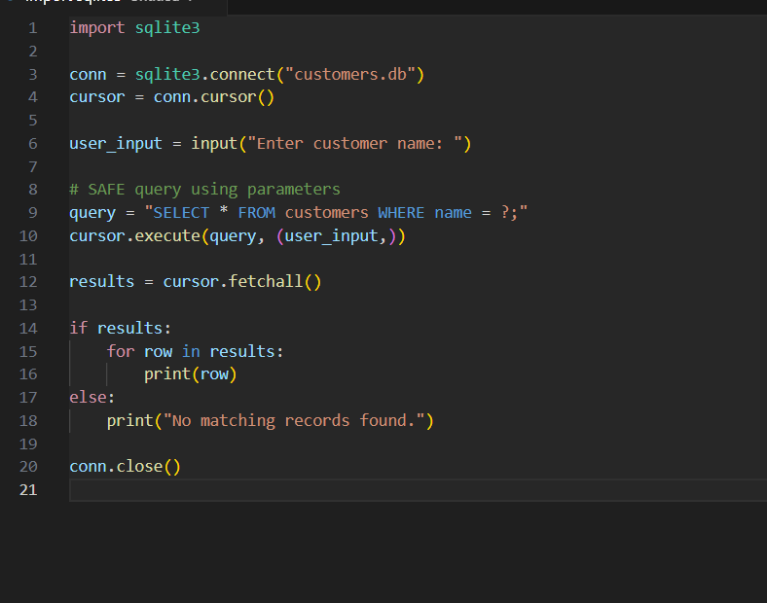  Lab Question 2: Hardcoded API Keys in AI-Generated Code  An AI-generated script for accessing a weather API contains the API key directly inside the code. This can lead to credential leaks if the code is shared publicly.  - Task 1: Identify and explain the vulnerability. Modify the script to securely fetch the API key from an environment variable.  - Task 2: Use AI assistance to generate unit tests that check whether the script throws a clear error when the environment variable is missing or invalid.  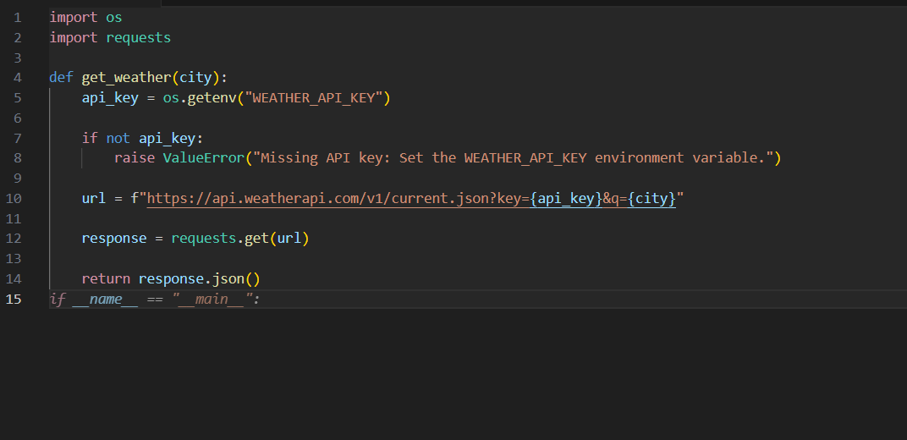  Lab Question 3: Command Injection in AI-Generated File Utility  An AI tool generated a shell-based Python function that takes user input for filenames and executes a system command (os.system("cat " + filename)), creating a command injection vulnerability.  - Task 1: Demonstrate the vulnerability by entering a malicious filename input (e.g., "test.txt; rm -rf *"). Document the outcome in a controlled environment.  - Task 2: Secure the script by replacing the unsafe method with Python’s built-in file I/O operations. Add exception handling for missing or inaccessible files.  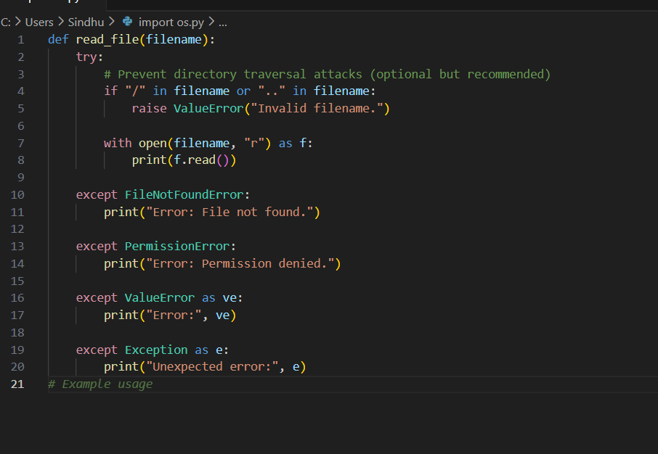 |  |  |  |  |  | Week 10 - Friday

